***SWIGGY ANALYSIS***

Here I have written in graph form the default daily transactions of swiggy with order per day verses month.

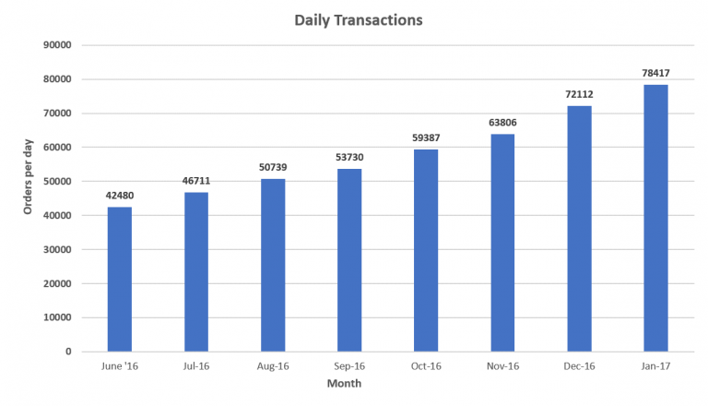

**Marketing Mix Analysis of Swiggy**

Product: Swiggy is one of the popular companies to supplies ordered food and beverage items. The online order food and you can also make online payment or on delivery. Customer makes online order by going swiggy app from his or her neighbored restaurant. If goes well get swift delivery of food and beverage items.

Price: Its success depends on keeping delivery prices extremely low. In Bangalore, for example Swiggy gives free delivery for any order over Rs. 250 and a delivery fee of Rs. 35 for orders below 250. It generates revenue by taking a cut from the restaurants itself.

Place: Swiggy has spread its presence to few cities in India like Bangalore, Gurgaon, Pune, Chennai, Delhi, Hydrabad, Kolkata and Mumbai. It has its headquarters base at Bengaluru in Karnataka and has established its corporate offices at Hydrabad in Telangana and Gurgaon in Haryana.

Promotion: Word of mouth. Online marketing strategy. Interesting ad campaigns like #SingWithSwiggy and #DiwaliGharAayi. Its facebook page is very popular and active as it offers regular updates and encourages active participation.

Competition: Major competitors include foodpanda, Zomato, Tinyowl.

Strengths: Quick Delivery, Good Brand Image, Trained people for making delivery. Good Organizational Structure and managers. Better customer Support. Wide range of restaurants offered.

Weaknesses: Orders only available from restaurants that are located in the zone of the ordered placed. Low awareness of Brand or low marketing. Delivery charges in some cities differences in menu and app price.

Opportunities: Pioneer in food delivery Business. Growing market for potential customer market share. Only few Oder food delivery businesses cost effective and good quality food.

Threats: Present customer base is low, increase the health consciousness, and increase the potential competition.

